**GO Util Package Documentation**

1. Utility Package Integration

IsPrime

Uses a loop to check for division from 2 to check if there are divisors and returns it again indicating that it is prime

Reverse String

Revereses the character of any given string iterates through the length of the string to swap the characters from beginning to end.

SumOfSlice

Computes the sum of all integers in a given slice it uses a for loop in range of the slice to add all the elements and return the results.

Factorial

Calculates the factorial of a given integer n.

1. Unit Tests

IsPrime

ReverseString

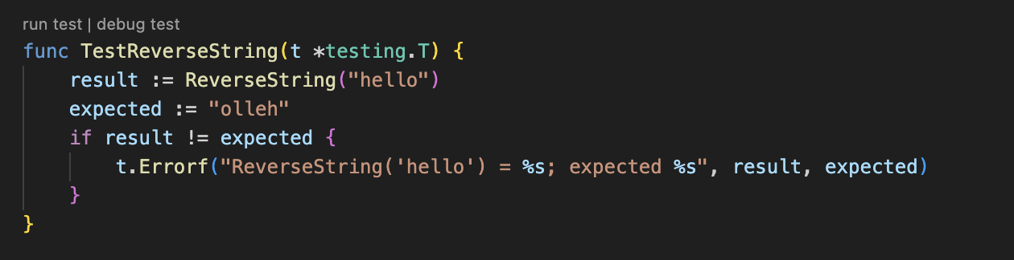

SumOfSlice

Factorial

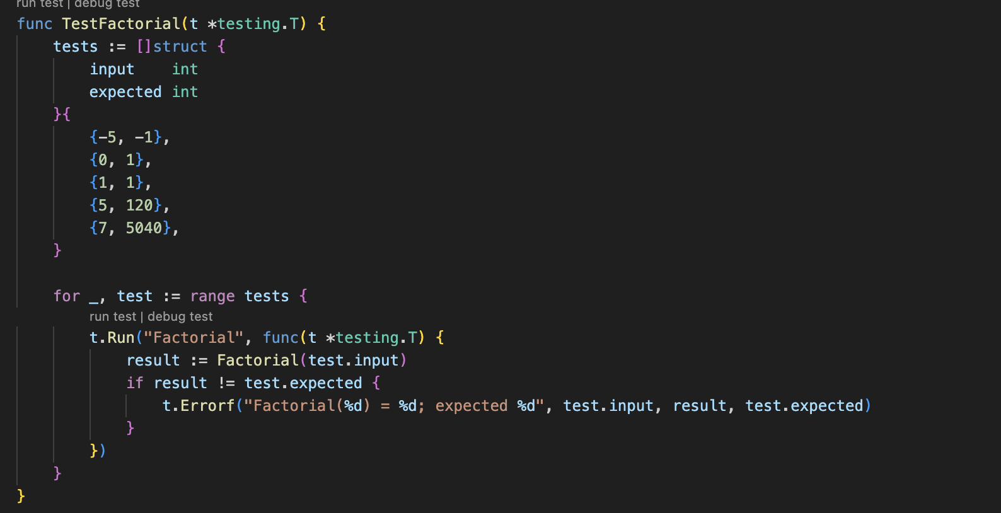

1. Benchmarks

ReverseString

IsPrime

SumOfSlice

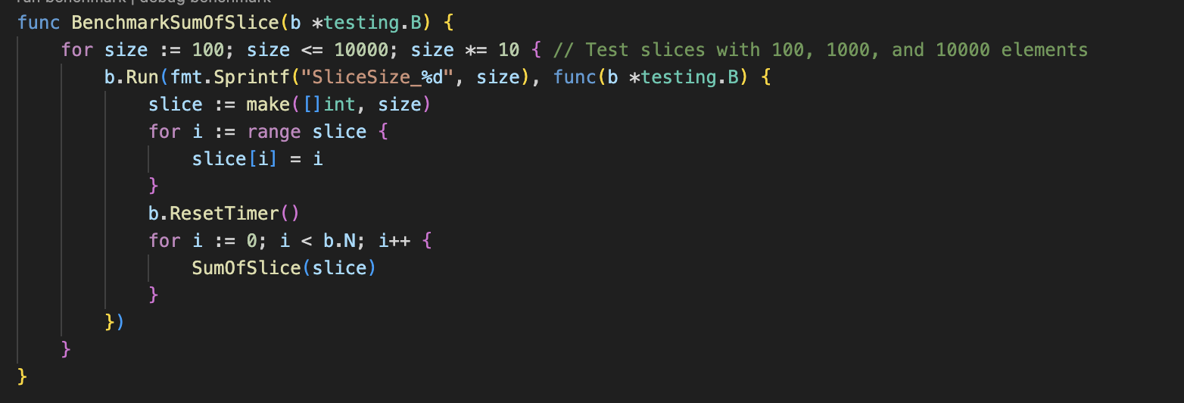

1. Coverage Analysis

Output from “go test -coverprofile=coverage.out”

Output from “got test -cover”

We achieved the necessary requirement of 90% and achieved 94.7%

As seen in the output from coverage.out there is 1 0 next to 4.12,16.3 which is this specific part of the code below

It wasn’t covered due to no test cases being provided where N is equal to zero.

**Table Driven Tests**

Provided a clear and organized way to to test various different scenarios for each of the functions. By defining the inputs and expected outputs in a format, it became easier to cover edge cases and explore different testing scenarios. This approach saved time and ensured proper and a well comprehensed testing for the functions.

**Key Finding from Benchmark Tests**

The Benchmark tests revealed that each of the functions performed exceptionally with the exceptions of IsPrime where it showed slower performance for larger numbers due to the loop used.